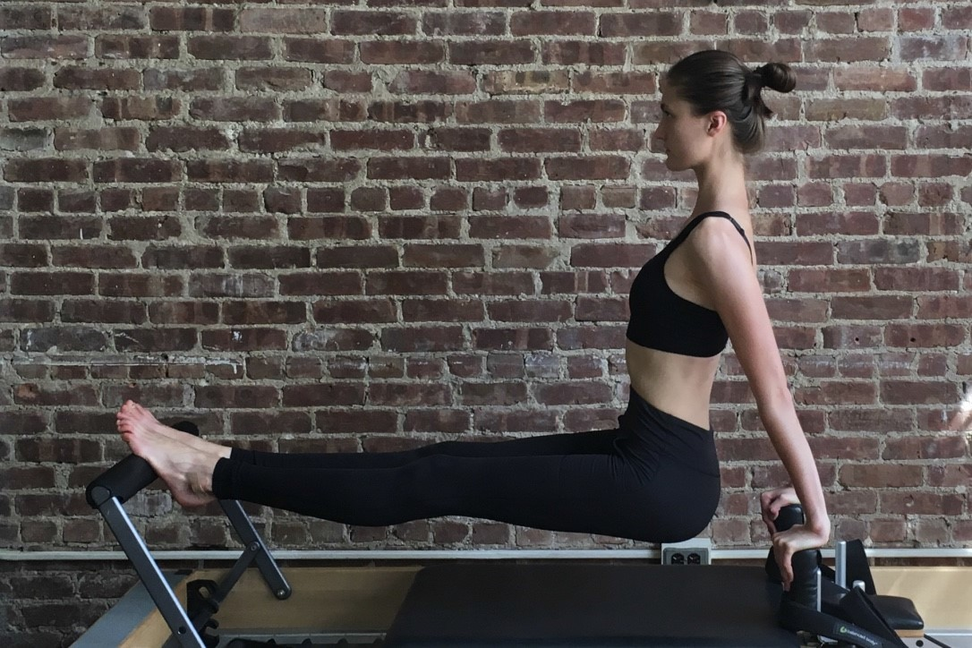

2018 SCHOOL CATALOG

39 East 20th Street New York, NY 10003 212-727-7896

info@gramercypilatesnyc.com www.gramercypilatesnyc.com

Table of Contents:
Introduction……………………………………………………………………………………………….….…………………………………………………………………………………………….…….……3 Mission………………………………………………………………………………………………………….………………………………………………………………………………………….………………3 Goals…………………………………………………………………………………………………………….………………………………………………………………………………………………….………3 Teacher Biographies…………..…………………………………………………………………………………………………………………………………………………………………………………..3 Program and Courses……………………………………………………………..……………………………………………………………………………………………………………………………3-4 Program Costs………………………………………………………………………………………………………………………………………………………………………………………………………….4 Studio Facilities………………………………………………………………………………………..……………………………………………………………………………………………………………..5 Admission Requirements……………………………………………………………………………………….……………………………………………………………………………………………….5 Enrollment Procedures……………………………………………………………………………………………………..…………………………………………………………………………………….6 Leave of Absence……………………………………………………………………………………………………………………….…………………………………………………………………………..6 Conduct Policy…………………………………………………………………………………………………………………….………………………………………………………………………….6 Dismissal……………………………………………………………………………………………………………………………………….………………………………………………………………………..6 Educational Services…………………………………………………………………………………………………………………….…………………………………………………………………………6 Grading System…………………………………………………………………………………………………………………………….…………………………………………………………………….6-7 Progress Policy………….…………………………………………………………………………………………………………………………………………………………………………………………….7 Transfer of credit policy…………..………………………………………………………………………………………………………………………………………………………………………………7 Refund policy……………………………………………………………………………………………………………………………………………………………………………………………………………7 Student Grievance Procedure………………………………………………………………………………………………………………………………………………………………………………7-8 Sexual Harassment Procedure…………..……………………………………………………………………………………………………………………………………………………………………8 Access to student files…………………………………………………………………………………………………………………………………………………………………………………………..8 Satisfactory Completion………….………………………………………………………………………………………………………………………………………………………………………………8

Introduction:

This specialized 454 hour Mat and Equipment comprehensive Pilates Teacher Training Program includes the Classical Pilates repertoire, contemporary and advanced teaching techniques as well as information typically only found in Special Population/Injury/Rehab and Continuing Education courses. It has been structured and designed to facilitate the learning process and enable prospective Pilates teachers to truly understand how and why Pilates exercises really work for both healthy clients and those that are in need of modifications and/or different exercise prescriptions and guidelines. The Program includes supervised in- depth course lecture hours, hours of self-practice, observation, student-to-student teaching, additional lecture observation, and apprentice teaching and hours of personally supervised student teaching.

Mission:

To produce Pilates teachers that are well-versed about the kinesiological principles developed by Joseph Pilates as well as implementing new science and information from the 21st century. This combination of education will prepare our students to provide safe and effective sessions for every type of client they encounter. Further, to guide potential students towards becoming PMA certified teachers.

Goals:

-Offer our Program to Pilates studio and schools both nationally and internationally in 2018 through our new educational arm, the Gramercy Pilates Institute.

-Obtain a New York State vocational license by the end of 2019.

-Have all studio teachers come directly from our Teacher Training Program.

-Graduate at least three new teacher trainers by the end of 2019

Teacher Biographies:

Ernie Fossa, Owner and Director

Ernie has been teaching Pilates since 2004. He received his Pilates Certificate from the renowned Kane School of Core Integration known for its anatomical and biomechanical approach to fitness. He is a member of the Pilates Method Alliance, (PMA), and experienced in both classical and contemporary Pilates. Ernie also holds certificates in Gyrotonics including the Gyrotonic Tower Expansion System and Jumping and Stretching Board. He's also certified to teach the Core Align. Ernie created the Gramercy Pilates Teacher Training Program with an integrated approach to anatomy, biomechanics and movement in mind. This integrated approach has facilitated the learning process for prospective Pilates teachers and allowed them to focus more on the reality of teaching. The program offers a classical choreography foundation with a contemporary approach to anatomy and biomechanics and provides in- depth knowledge of why exercises work for a variety of clients including those with medical conditions and physical restrictions.

Kim Fielding, Director of Teacher Training

Kim Fielding holds a certificate in from Balanced Body and The Method Pilates as well as being PMA Certified. She has been in the fitness industry for 25 years and has been teaching Pilates for over 15 of those years. She received her B.A. in Psychology and did a Master’s program at Springfield College in Health Promotion/ Wellness Management with advanced study in Counseling. She was a teacher in the Mind Body Fitness training program with other faculty members including Lesley Powell, Doris Pasteleur-Hall and Dr. Martha Eddy at Movements Afoot. She taught the Pilates repertoire and question & answer program to go along with the Physical Mind Institute, The Method Pilates certificate. She also taught students Balanced Body Pilates Repertoire on a weekly basis. She has specialized training in MS and Parkinson’s disease, Somatics, Laban and Bartenieff Fundamentals. Fielding studied in the Somatic Movement Teacher Training program, Dynamic Embodiment, with Dr. Martha Eddy.

Programs & Courses Offered:

We offer a 454 hour Mat and Equipment Teacher Training Program. Upon Completion of the Mat Program a certificate is awarded and upon completion of the Equipment Program a certificate is awarded.

MAT PROGRAM (108 HOURS)

Lecture Session Courses (Total 48 hours personally taught by Kim Fielding or Ernie Fossa)

History of Joseph Pilates

The Skeleton and Muscular Systems

Integration of Anatomy, Biomechanics, and Movement

Effective Cueing and The Art of Observation Fundamental Movement Principles
Beginner to Advanced Mat Choreography

Studio Practice Time (Total 60 hours)

20 hours of self-practice

10 hours of unsupervised teaching (student teaches student) 10 hours of Mat Class observation
10 hours of supervised teaching (Personally supervised by Kim Fielding or Ernie Fossa) 10 hours of Mat Class apprentice teaching.

EQUIPMENT PROGRAM (346 HOURS)

Lecture Session Courses (72 hours personally taught by Kim Fielding or Ernie Fossa)

Beginner to Advanced Equipment Choreography including Reformer, Cadillac, Chair Barrel and other Props Teaching Methods and Techniques for Beginners, Intermediate and Advanced Clients
Facilitating Client Alignment and Manual Teaching Special Populations and Clients with injuries.

Studio Practice Time (Total 274 hours)

80 hours of self-practice

50 hours of unsupervised teaching (student teaches student)

50 hours of Private Session and Equipment Class observation, (25 hours each).

30 hours of supervised teaching (personally supervised by Kim Fielding or Ernie Fossa). 24 hours of observing future Mat and/or Equipment lectures.
40 hours of apprentice teaching.

Program/Course Costs:

MAT PROGRAM

- Pay in Full with registration: $1,700

- Down Payment Option: $1,800; Pay $400 with registration, then $1,400 before the first day of Mat Program.
*Payment Includes: Manual, Exams, Self-practice hours, Supervised and Unsupervised teaching.
EQUIPMENT PROGRAM
- Pay in Full with registration: $4,800

- Down payment Option: $5,000; Pay $800 with registration, then $4,200 before the first day of Equipment Program. MAT & EQUIPMENT
PROGRAM REGISTRATION

By purchasing both programs together at the same time, you will save $650! Pay in full with registration: $5,850
*Payment Includes: Manual, Exams, Self-practice hours, Supervised and Unsupervised teaching.

Facilities:

We have designed our studio with the exclusive Gramercy neighboring park in mind with leafy green walls, sunny lighting, and a wide-open floor plan that covers 2,500 square feet of training area. We offer two dressing rooms, one bathroom equipped with shower and a full kitchen where the students may store food and beverages.

We’ve heavily invested in the best Balanced Body Pilates Equipment in order provide students a safe and effective learning and teaching experience. The equipment in our facility includes:

12 Reformers with Tower Attachments 2 Cadillacs
1 Ladder Barrel

12 Spine Correctors

2 Wunda Chairs

4 Exo Chairs

1 Foot Corrector

1 Spring Board

15 Mats

We also use props such as the Magic Circle and Physio ball

Admissions Requirements:

Mat Program Admission Requirements Prospective Mat Program Students must:
-Must have a basic knowledge with the Classical Pilates Mat exercises. Without the experience with Classical Pilates Mat exercies they will be required to take a minimum of 5 Mat Classes at a cost of $115 at Gramercy Pilates NYC before they can be considered for admission to the Mat Program.

–Must be at least 18 years of age.

–Must have a high school diploma. Equipment Program Admission Requirements
Prospective Equipment Program Students must:

-Meet with the Program Director to review the Equipment manual to fully understand the details and the level of learning the program is offering.

- Must have a basic knowledge with the classical Pilates equipment exercises. Without the experience they will be required to take a minimum of five equipment classes at a cost of $200 at Gramercy Pilates NYC before they can be considered for the teacher-training program.

-Must have past or present enrollment in the Gramercy Pilates NYC Comprehensive Mat Program or another Mat program that is from a registered PMA Pilates school Approval Program.

–Must be at least 18 years of age.

–Must have a high school diploma.

*Please Note: Gramercy Pilates NYC does not guarantee employment, certification or success as a Pilates Teacher upon completion of its Mat and/or Equipment Teacher Training Program.

*All admissions decisions are based on clearly published admissions criteria. No applicant will be denied on the basis of race, national origin, color, creed, religion, sex, age, disability, gender identity, gender expression, or sexual orientation

Enrollment Procedures:

Meet with the Program Director to review the Mat manual to fully understand the details and the level of learning the program is offering. Once your application is submitted and approved, an enrollment agreement must be completed and signed along with the payment for tuition. Payment can be made in full when the enrollment is signed or completed before the program start date.

Attendance Requirements:

For successful completion of the Mat and/or Equipment programs, it is required that all hours of course lecture be attended. If a student misses any part of the course, lecture must be made up privately at a cost of $75 per hour. For every 2 hours of course lecture hours missed, one private hour of lecture is required. If a student misses only one hour of course time, they may attend one hour of lecture at a future course date.

All students self-practice, observation, student to student teaching, supervised teaching, lecture observation and apprentice hours must be also been completed.

In the case of any emergency, whether it is an hour, days, months, or leave of absence, for medical or personal reasons, proper documentation will be required to substantiate a student’s withdrawal or take a leave of absence.

All course lecture hours and practice time must be completed within one year of the time the course lecture begins.

Leave of absence:

It is expected that students attend and finish each lecture series and the student practice hours within one year. If a student requests a leave of absence that is voluntary (their decision), they will provide written explanation and meet with the studio director. The meeting will include an agreed upon additional time the student will take to finish the program at no additional cost.

Conduct Policy:

All students are required to act in a mature manner and respect other students, teachers, managers and owners of the studio and the studio property including all Pilates equipment. This relates to when a student comes in for their Program lecture hours or doing any practice time in the studio. The studio reserves the right to dismiss any student from the Program for consistent disruptive behavior.

Dismissal:

The studio Director may permanently dismiss any student for violation of any rule or regulation as set forth in the published school enrollment agreement. The studio Director may consider a student who was dismissed to resume the Program for re-admittance based on the student’s sincere desire to adhere to the studio policies of conduct.

Educational Services:

Supervised Teaching

Our Program relies heavily on personal supervision given by both the Program Director and the Studio Director.

Included in our Program are Supervised Teaching Hours which are required hours in the Program. These hours are regularly scheduled during the week for students to come in and teach a friend or family member. Students are required to do at least 10 Supervised Teaching hours for the Mat Program and 30 Supervised Teaching hours for the Equipment Program.

The Session is supervised as follows:

-During the Session, the Director may make corrections with the students teaching.

-During the Session, the student may ask the Director questions about the teaching.

-After the Session, the student will meet with the Director to review the Session.

-We provide additional education with a small library in the studio.

Grading System:
Grades are based on test results. A grade of 75% or more out of 100% is a passing grade.

Mat Program Grading.
There are two formal tests during Mat Program lecture.
One written test is given after the Anatomy/Biomechanics/Movement Principle/Cueing and Observation lecture series. The written test has written answer questions, true and false questions and multiple-choice questions.

There is a manual test given after the teaching of the classical Mat exercises. Students are paired to teach each other and in a group class setting. Grades are given to students based on their ability to teach the Mat Choreography. Grades are based on the following categories:
-Client/Class Assessment (0-10 pts.)
-Modifications (0-10 pts.)
-Use of Fundamental Movement Principles (0-25 pts)
-Cueing and Observation (0-10 pts.)
-Selection of Exercises (0-25 pts.)
-Session Flow (20 pts.)
Both tests must be passed as well as all student practice and teaching hours completed for a student to receive their Mat Certificate and progress into the Equipment Program.
Equipment Program Grading.
There is a final written test and manual test once all Equipment lecture hours are attended and all required student practice and teaching hours are completed. Both require at least a 75% grade to pass.
The final written test includes information that encompasses both the Mat and Equipment lecture courses. This written test includes written answer question, true and false and questions regarding special populations and clients with medical conditions.
The final manual test is scheduled once the written test is passed. The student is assigned a client they have never met. The test includes the following categories of grading:
-Client Assessment (10 pts.)
-Use of Fundamental Movement Principles (0-25 pts.)
-Proficient use of all apparatus (0-25 pts.)
-Cueing and Observation (0-10 pts.)
-Session Flow (10 pts.)
-Assessment use in session (20 pts.)
Both tests must be passed for the student to receive their Equipment Certificate and move forward to take their test for PMA certification.

Progress Policy:

Students must pass all Mat and Equipment Program test to continue onward and receive their Pilates Certificate.
The grading system shown above is used to qualify students for advancement. If a student fails a test they may retake the test as many times as necessary at a cost of $75. Further progress evaluation is done during students “Supervised Teaching” hours, which are required hours in the Program. Here, the Program Director supervises students’ sessions and when necessary provides both verbal and/or written feedback, these progress evaluations are done each time a student does a “Supervised Teaching” hour. There are 10 hours of supervised teaching during the Mat Program and 30 hours of supervised teaching during the Equipment Program.

Additional progress evaluation is done when students begin their Apprentice teaching at the studio. There are a total of 40 Apprentice teaching hours each student is required to do. The teaching is a combination of Private sessions and Group Classes. When necessary, students are given verbal and/or written feedback and progress evaluations after each Apprentice teaching session.
During the students Supervised teaching and Apprentice teaching, students are assessed for the following:
-Assessing their clients
-Providing the proper exercises and modifications in the one-hour session.
-Teaching the Fundamental Movement Principles
-Cueing and Observation
-Session Flow

In the event that students are not progressing in a positive manner, the program director will meet with them to discuss them completing additional supervised teaching hours to help them progress.

Transfer of credit policy:

The Gramercy Pilates NYC Program and Studio Directors evaluate the transfer of students from other Pilates studios on a case-by-case basis. There is no guarantee of the student’s credits. To apply for a transfer a student must meet with the Program Director, provide a clear summation of their program transcripts or summation from the studio they are transferring from and pay a review fee of $250. The Program Director will provide a full evaluation of the transferring student including the level of proficiency the student shows during an audition. The audition will include a practical evaluation where the program director will determine if the student’s transfer credits can be applied.

Refund policy:

If the student leaves having completed 25% or less of the program, the refund is 75% less cancellation charge; if the student leaves having completed between 25% and 50% of the program, the refund is 50% less cancellation charge; if the student leaves after 50% of the program, there is no refund. Cancellation charge is 10% of program fee.

Student Grievance Procedure:

Students with grievances adhere to the following protocol:
- Speak directly to the source of grievance. If this is not a reasonable option, or if such an option does not remedy the situation, speak with the Director.
-If this is not a reasonable option, or if such an option does not remedy the situation, document all relevant facts and send to PSAP2pilatesmethodalliance.org

Sexual Harassment Procedure:

Definition:
Sexual Harassment is defined as unwelcomed verbal, visual, or physical conduct of a sexual nature that is severe or pervasive and affects working conditions or creates a hostile work environment.
Gramercy Pilates NYC abides by the No Tolerance Policy to sexual harassment in the work place. Federal, State, and local laws prohibit sexual harassment and provide protection to employees, which may include civil, and in some cases criminal remedies. In an effort to prevent such illegal harassment, this company will promptly and confidentially investigates all complaints of sexual harassment. Appropriate action, including possible termination, will be taken against those who violate this policy. No employee, or student, of this company is exempt from this policy. (See EEOC definition in Title VII of the Civil Rights Act of 1964).
Individuals who are found to have sexually harassed or knowingly filed a false complaint of sexual harassment against another individual shall be subject to disciplinary action, including termination of employment and/or enrollment in the program. Any student who feels they have been subjected to sexual harassment should document any information with relevant facts and contact the studio director.
Sexual Harassment Procedure:
- Speak directly to the source of grievance. If this is not a reasonable option, or if such an option does not remedy the situation, speak with the Director.
-If this is not a reasonable option, or if such an option does not remedy the situation, document all relevant facts and send to PSAP2pilatesmethodalliance.org

Access to student files:

Documents listed below are kept confidential on file at Gramercy Pilates NYC. Students are welcome

to access them at the studio Monday through Friday from 9:00 am to 5:00 pm. Student information on file includes:

- Personal information/application form including non-discrimination policy

- Signed enrollment agreement

- Signed sexual harassment policy

- All test and progress reports

- Picture ID

Satisfactory Completion:

Students who satisfactorily complete the Gramercy Pilates NYC Mat and/or Equipment Teacher Training Program receive Pilates Certificates of Completion. Each Program has its own Certificate. When a student completes all the required lecture hours, teaching hours and passes all tests for the Mat Program they receive a Mat Certificate of Completion and when they complete all of the required lecture hours and teaching hours and pass all tests for the Equipment Program they receive an Equipment Certificate of Completion.

